LAB 1: Site Selection Using Model Builder

Submitted by: Ryan Nguyen (216334336)

Submitted to: Afnan Ahmad

Submitted on: January 27, 2022

Course code: LSE/ESSE 4600 GIS and Data Integration – W2022

Introduction

In this lab, students are to create suitability maps to find the best locations for schools with respect to distance from school, distance from recreational sites, and elevation. The suitability maps will be created using varying cell sizes which will be used to define weights to select an optimal location for the school. This lab was developed through ArcGIS Pro and with a given data set.

Methodology

After creating an ArcGIS Pro project and importing the given dataset, I used these symbols to represent the legend for schools and recreation sites:

Figure : Legend Symbols for Schools and Recreation Sites

**Question 1**

Following the tutorial, a model builder was used to create a suitability model to find the optimal location for a school. This model used the slope and Euclidean distance tools with schools, recreation sites, and elevation as its input:

Figure : Model Builder for Suitability Model

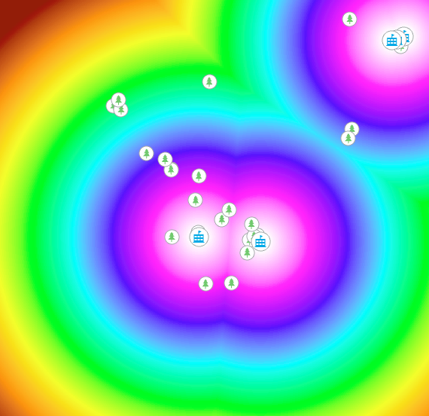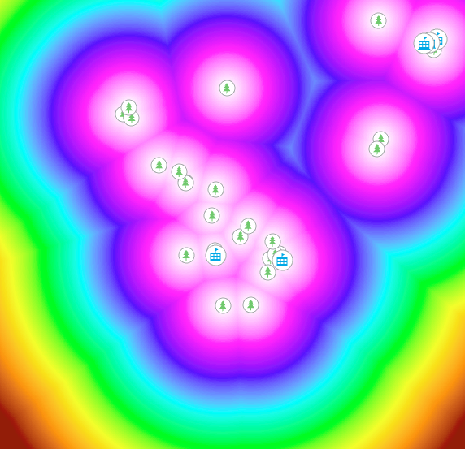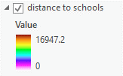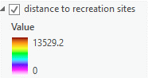

Legends

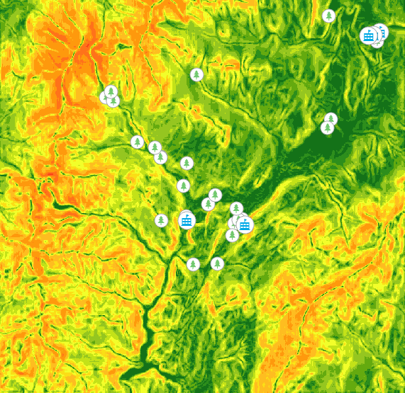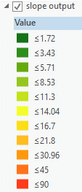

Figure : Created Layers from Suitability Model

After adding the classify tool and reclassing the number of classes to 10, I created new layers from the existing ones:

Figure : Existing Model Builder Reclassified

Legends

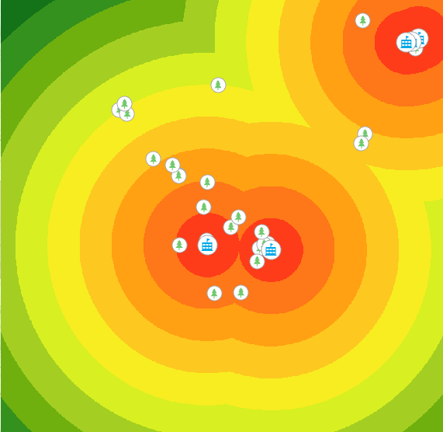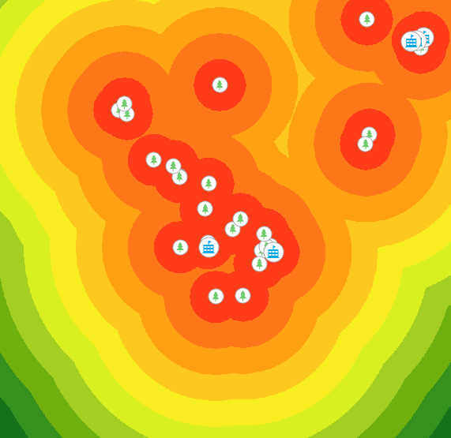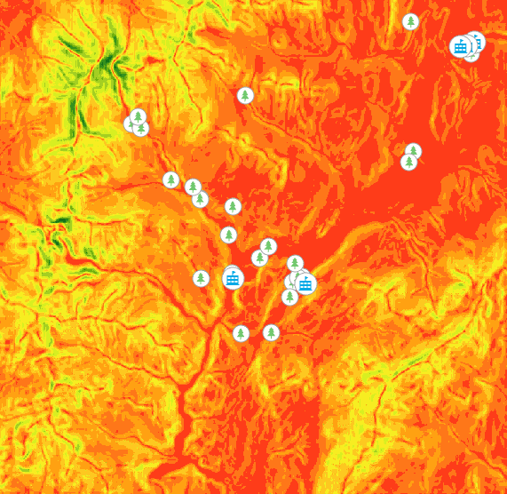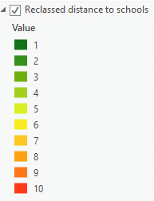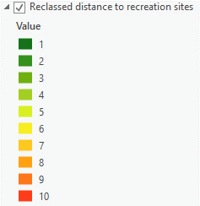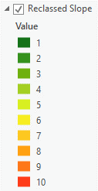

Figure : Reclassified Layers

Next is to add a weight parameter to the 4 inputs to develop our suitability layer.

Figure 6: Renamed Inputs for Weight Tool

Input names are different than the display names along with the addition of landuse

Reclass_EucD1 = Reclassified Recreation Site 🡪 50% influence

Reclass_EucD2 = Reclassified Schools 🡪 25% influence

Reclass_Slop1 = Reclassified Slope 🡪 13% influence

Landuse 🡪 12% influence

Running this model will produce our suitability layer. Suitability areas with a value of 10 are **most optimal** while areas with a value of 0 **are least optimal**. [Figures 3 and 5] were created using a cell size of 30, the following models will be of reclassified layers for the suitability layer using cell sizes 30, 60, 90, and 120. The cell sizes were manipulated by changing the **cell size value in the raster analysis input of the environments option in the model builder.**

Figure 7: Legend for Suitability Layer

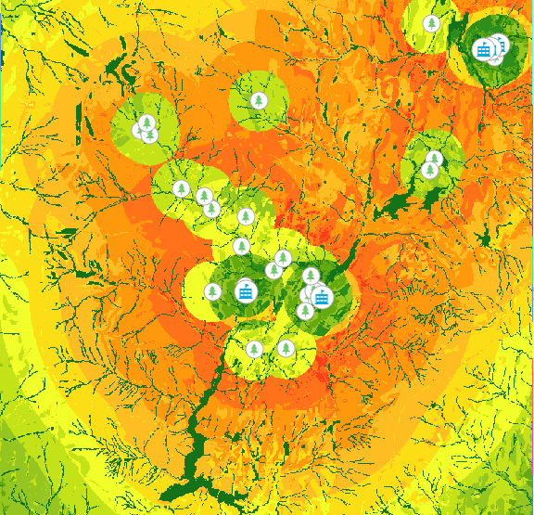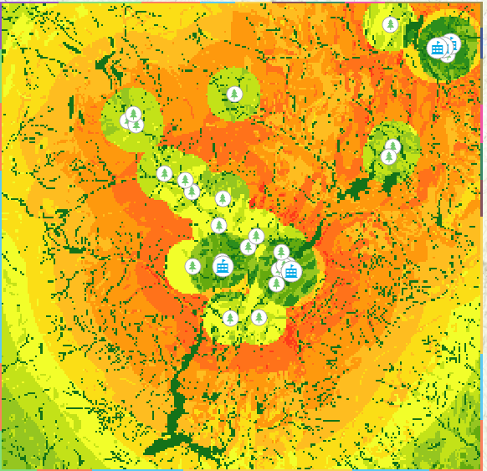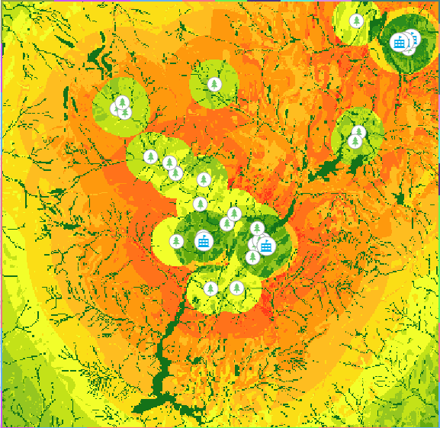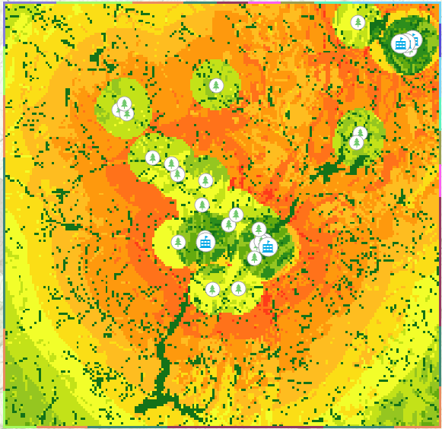

Cell Size 30

Cell Size 60

Cell Size 90

Cell Size 120

Figure 8: Suitability Layer for cell sizes 30, 60, 90, and 120

[Figure 9] is the suitability layer filtered for optimal areas.

Figure 9: Filtered Suitability Layer for Cell Size 30

We can filter out areas that are too small for the school site but after doing so, there wasn’t much of a difference, this is what the end of the model builder looks like:

Figure 10: Filtered Suitability Layer of Figure 8 for Majority Filter

Figure 11: Final Model Builder Diagram

**Question 2**

The differences between the cell sizes are that the lower the cell size is, the greater quality layer image it produces and vice-versa. Cell size 30 produced the highest quality image while cell size 120 produced the lowest quality image. There are no notable changes in the overall shape of the layer besides the quality. The changes in quality can minorly change the shape of the image by producing a less sharp version of the layer image.

These results are affected due to the amount of area the cell size encompasses. Bigger cell sizes are to look more “blobby” and take a smaller number of pixels to encompass the shape of the layer. That’s why smaller cell sizes are of higher quality as their small shape can create a more accurate image by using more pixels.

An optimal cell size depends on the application of the project. In this case, we are trying to find an optimal location for a school. This requires a plot of land that we can estimate to be around 100m by 100m to place a school. I would consider a cell size that reflects this dimension requirement, so choosing a cell size of 120 seems optimal as it would accommodate for the space required to build a school. For more precise, smaller objects like trash cans or bus stops, I would choose a lower cell size like 30.

**Question 3**

These results will be produced using a cell size of 30 but with varying weights applied. For the first reweight, I switched the weighting of the distance from recreation sites and school:

Distance from recreation sites (Reclass_EucD1): 25%

Distance from schools (Reclass_EucD2): 50%

Figure 12: First Reweight Parameters

For the second reweight parameters, I made all the inputs an even 25% influence.

For the third reweight parameters, I made all the inputs 30% with land use being 10% influence.



Original

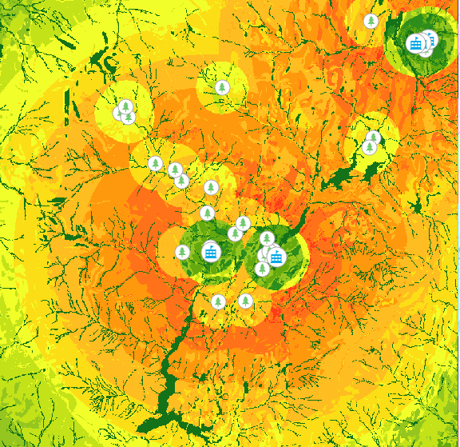

First Reweight

Second Reweight

Third Reweight

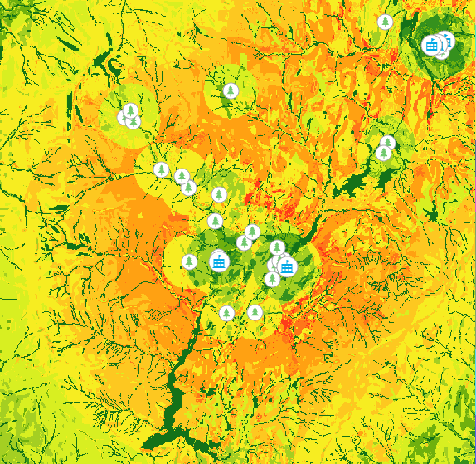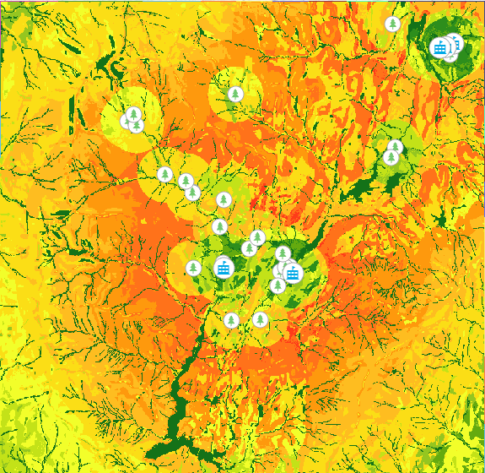

Figure 13: Figures of Suitability Map with Varying Weights

Original

First Reweight

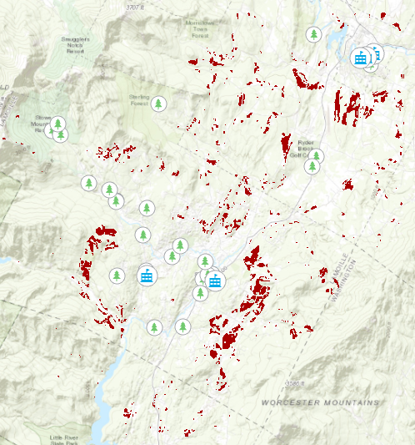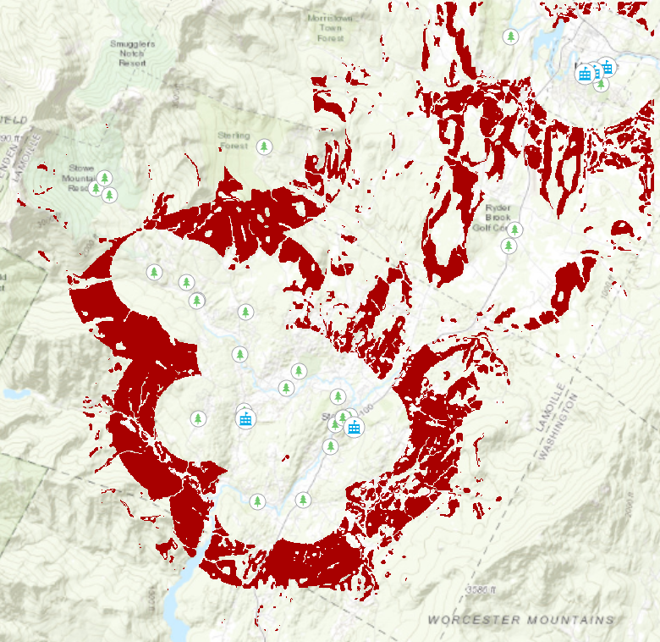

Second Reweight

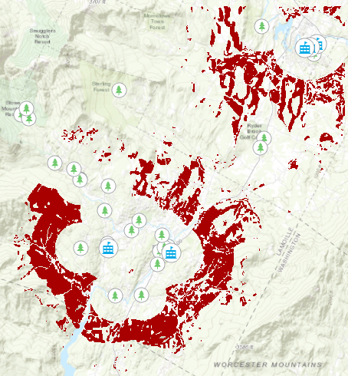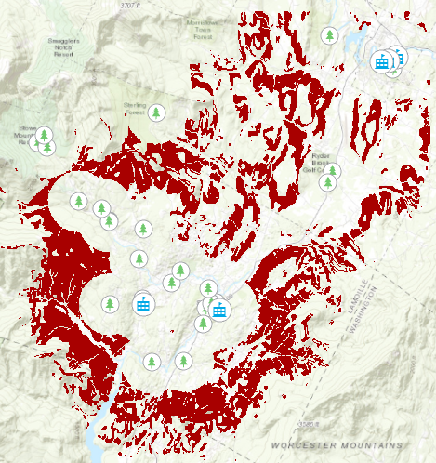

Third Reweight

Figure 14: Figures of Optimal Location with Varying Weights

After analyzing the reweight classes, here is what I found:

**First Reweight**

It seems this weighting produced better suitability locations with an increased weighting in distance from schools as the greener areas (least suitable locations) around the recreation sites have a more orange tinge to them (most suitable locations). But looking at the optimal layer map, we have less optimal area than we did in the original. In this reweight, we are missing the optimal locations in the north-west area of the layer. To conclude, it seems that this reweight produces an overall better suitability map, but at the cost of optimal location area than the original.

**Second Reweight**

This reweight produces significantly less optimal locations than the original and the rest of the reweights. It produces mostly average suitability areas with values ranging mostly from 4-6 (Yellow tinge meaning not good or bad locations) across the layer. This could be correlated to that every input parameter has equal influence which doesn’t have a strong preference towards an input in its weighting.

**Third Reweight**

This reweight produces the largest optimal locations than the original and the other reweights. I believe that because land use was an optional input, giving it less weighting would increase the influence of the other parameters. We can see the shade of orange (optimal locations) is more prominent in this reweight whereas in other reweights we can see the separation of yellow and orange shades.

**Verdict**

The third reweight produced the best suitability layer in terms of producing the most optimal locations. I believe to create the best suitability layer, would be not include land use as a weighting option which we can see its negative influence in the second and third reweight. I also think having the distance from the school and slope weighting should be equal with distance from recreation sites to be a little bit more than the other two inputs. Although it is difficult to measure the influence of slope in these 3 reweights, increased weighting of distance from recreation sites produced more optimal locations than distance from schools.

Resources

Esri (2010). Spatial Analyst Tutorial: Finding a site for a new school. Geographical Information Systems (GIS) and Data Integration. Toronto, Ontario, Canada: York University